AI Weather Wise - Provide smart weather forecasts and useful insights.

Team Id: SWTID-2026-4039

Team members:
1. Hansika T (Team leader)
2. Lavanya S
3. Sharmila S

4. Sandhya Devi S

Project Description
The AI Weather-wise is a robust Restful backend platform built with Node.js and Express.js, utilizing Mongo DB and Mongoose ODM for data persistence. It delivers real-time weather metrics integrated with Google Gemini AI to provide intelligent summaries and personalized recommendations according to current environmental conditions.
The platform provides secure JWT-based authentication, crypt password encryption, and a complete set of endpoints for managing favorite locations and retrieving weather insights. It also provides a reliable fallback mode so the APIs can function even when external API keys are unavailable, together with centralized error management and request sanitization.

Scenario-Based Case Study

Background
Alex is a travel enthusiast who often visits different cities and needs an easy way to monitor local weather conditions and get AI-based activity suggestions according to current forecasts.

Problem
- Challenges in efficiently tracking and managing several favorite weather locations.
- No personalized suggestions for outdoor activities or clothing.
- A need for weather summaries in natural language instead of only raw data values.
- No secure mechanism for storing and synchronizing preferences across devices.

Solution
AI Weather-wise offers a centralized service that manages weather data retrieval and AI processing. It maintains a secure User and Location database, enabling customized insights and automated recommendation processes through Google Gemini.

Usage
- User Usage: Handles favorite cities (CRUD), retrieves real-time weather, and requests AI insights for recommendations and summaries.
- Developer/Admin Usage: Checks API health, manages overall user registrations, and checks the weather/AI service integrations.
- Weather Application User: Uses the public weather endpoints to access current weather metrics without needing an account.

Outcome
By using AI and centralized data management, users spend less time interpreting raw metrics. The system maintains data integrity through Mongoose schemas and delivers useful, context-based weather guidance through Gemini integration.

1. Software Requirements
- Operating System: Windows 10/11, macros, or Linux (supports cross-platform operation).
- Node.js (v16 or above): Runtime environment for executing server logic and routing operations.
- Name (v8 or above): Node package manager used to manage project dependencies.
- Gemini AI SDK: Integration through @google/generative-air for generating natural language insights.
- Mongo DB: Document-based nosily database used for storing users, posts, categories, comments, and analytics metrics.
- Postman: API testing toolkit used to verify schema validation responses across protected administrative routes.
- Code Editor: Visual Studio Code or similar IDE environment.

2. Hardware Requirements
- Processor: Intel Core i5 (8th Gen or above) / AMD Risen 5 or equivalent.
- RAM: 8 GB minimum (16 GB recommended for concurrent instances of Mongo DB, processing layers, and execution nodes).
- Storage: 1 GB of available disk workspace.
Epic 1: PROJECT ARCHITECTURE
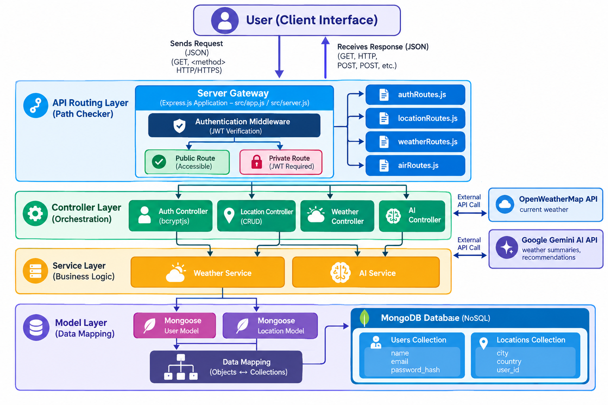
The AI Weather-wise application uses the MVC pattern to separate business logic from data handling. The Controller layer manages weather retrieval from OpenWeatherMap and creation of AI insights through Gemini, while the Model layer handles User and Location entities.

Component Definitions
- Interface: API tools such as Postman access different route paths to retrieve JSON entities.
- Express Server Gateway: Monitors network ports, maps specific HTTP methods (GET, POST, PUT, DELETE), processes JSON payloads, and manages CORS headers.
- Authentication & Role Matrix Middleware: Retrieves tokens from headers, verifies user context signatures, and checks whether the assigned role meets authorization requirements for protected resource paths.
- Granular Services (Logic Modules): Applies separate domain rules for blog lifecycles (Draft, Pending Approval, Scheduled, Published), comment queues, and system reporting indicators.
- Database Interface Layer: Mongoose translates operational application logic into efficient native MongoDB queries.
- AI Service Integration: Uses @google/generative-ai to create weather summaries and customized recommendations according to current temperature and conditions.

Entity-Relationship (ER) Diagram Details
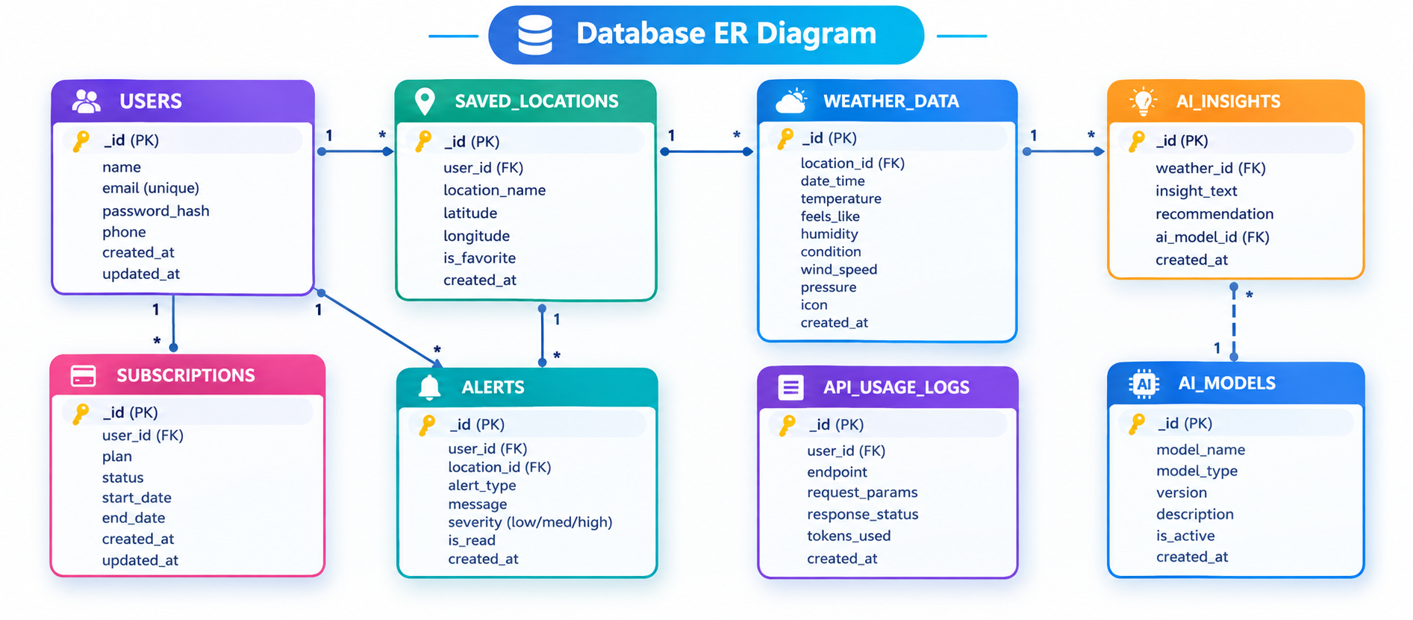The data structure manages User profiles and their related favorite Locations through logical relationships:

1. User Entity
- _id (Primary Key - ObjectId)
- name (String, Required)
- email (String, Required, Unique)
- password (String, Hashed, Required)
- role (String, Default: "reader")

2. Location Entity
- _id (Primary Key - ObjectId)
- user (Foreign Key referencing User Collection)
- city (String, Required)
- country (String, Required)
- createdAt (Date, Default: Now)

Key Structural Relationships
- User to Location (One-to-Many): One registered user can store multiple favorite locations.

Main Features
- Role-Based Route Guarding: Strict token validation prevents unauthorized roles from changing core settings.
- CRUD Blog Execution Engine: Complete schema handling for content definitions, status values, and asset assignment paths.
- Categorization System: Built-in tag indexes support filtering and querying for better discoverability.
- Comment Moderation Logic: Protected endpoints for updating moderation flags (approved, pending, spam).
- Sanitization Safeguards: Sanitizing payload parameters helps prevent XSS vectors and NoSQL parameter manipulation attacks.

Roles and Responsibilities
- Admin:
  - Handles user account management, including creating, deleting, or suspending accounts.
  - Supervises API health and system logs to track performance.
  - Checks and maintains database integrity.
- Registered User:
  - Handles creating and maintaining a list of favorite locations.
  - Starts requests for real-time weather information.
  - Uses the Gemini AI service for customized weather summaries and activity suggestions.
  - Manages personal authentication credentials, such as updating profile information.

User Process:
1. The user logs in or creates an account.
2. The user stores a favorite city through the API.
3. The user retrieves current weather metrics for that city.
4. The user requests AI-generated insights (summaries/recommendations) using the weather data.
5. The system verifies the JWT and provides the requested information.
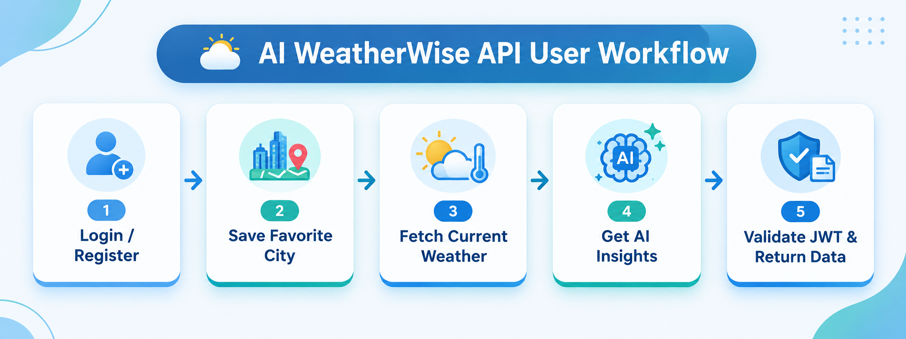
MVC Architecture Pattern
The system architecture organizes its source configuration layers using the Model-View-Controller design pattern to keep components separate:
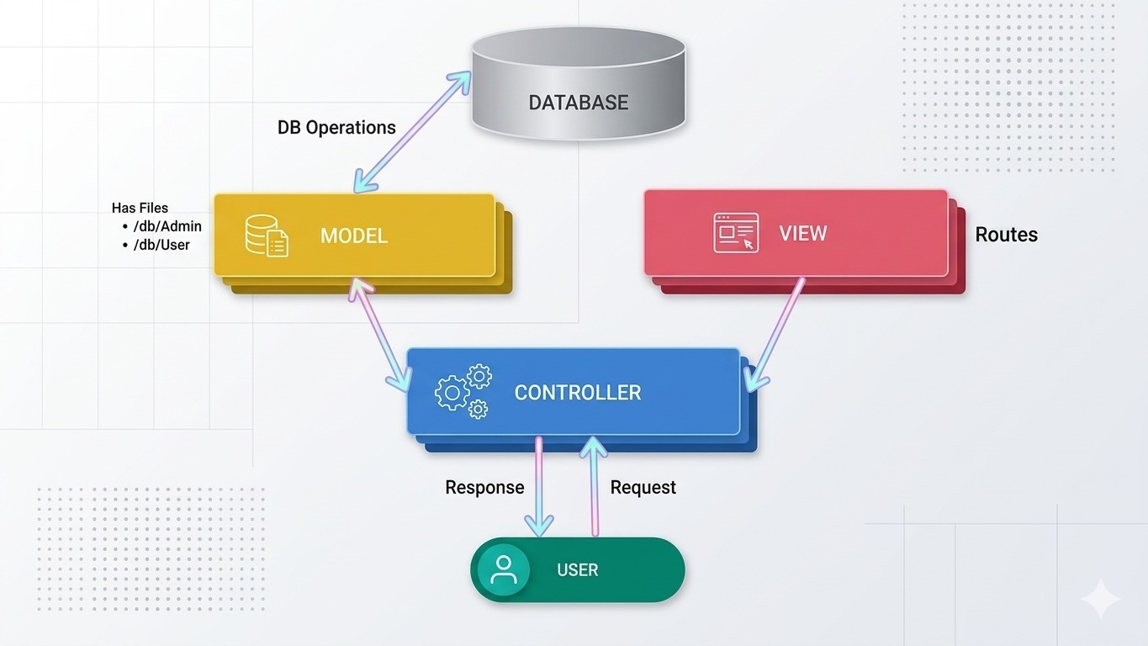

Model Layer (Data Blueprint)
Defines data structures through enforced Mongoose schemas that map specific fields to collection records inside MongoDB. It defines default states, indexing rules, and transformation settings before validation and persistence.

Controller Layer (Execution Matrix)
The central processing layer of the system. It receives requests from the execution routes, checks request constraints, sends processing tasks to models, and formats the resulting output into standard JSON response arrays.

View Layer (Routing Network Interface)
In this headless backend service, standard user-interface template views do not exist. Instead, the interface layer lives as an API Routing Layer. It links network requests on specified paths directly with their related controller handler logic.

Epic 2: Project Setup and Configuration

Creating the Project Directory
- Create a new folder named AI Weather wise
- Open the project folder in Visual Studio Code.
- Set up the project with Node.js and install the necessary dependencies.

Project Setup
Open the project directory in the VS Code terminal and run:
npm init -y
Install the necessary dependencies:
npm install express mongoose bcryptjs jsonwebtoken cors dotenv multer @google/genai
Install Nodemon for development purposes:
npm install --save-dev nodemon

Create the Following Files
- index.js
- .env
- package.json
- .gitignore

Create the Following Folder Structure

Environment Configuration
Create a .env file in the project root and configure the required environment variables.
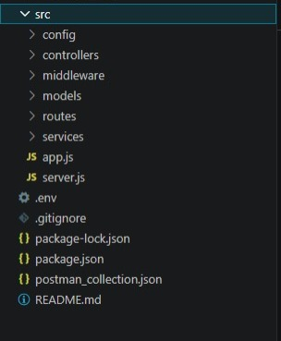
PORT=5000
MONGO_URI=your_mongodb_connection_string
JWT_SECRET=your_jwt_secret
GEMINI_API_KEY=your_gemini_api_key

Epic 3: Backend Development
The AI weatherwise backend is developed using Node.js, Express.js, and MongoDB, using a modular architecture. The application separates routing, controllers, middleware, models, and utility modules to make the code easier to maintain and scale. The backend provides secure REST APIs for authentication, study material management, AI-based content generation, and administrative operations.
Backend Structure:
Core System Script Implementations

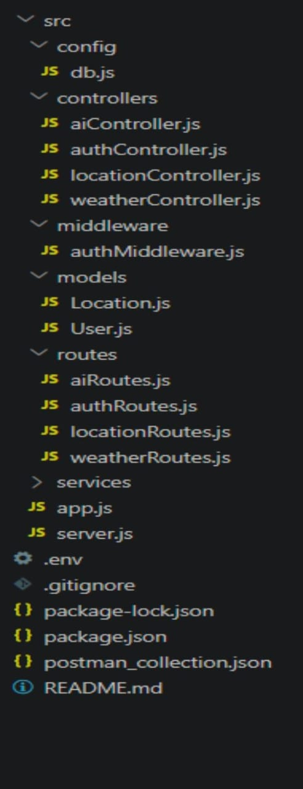

1. Application Starting Point (index.js)
The index.js file acts as the primary entry point of the application. It starts the Express server, loads environment variables, sets up middleware, establishes the MongoDB connection, registers API routes, and launches the server after a successful database connection.
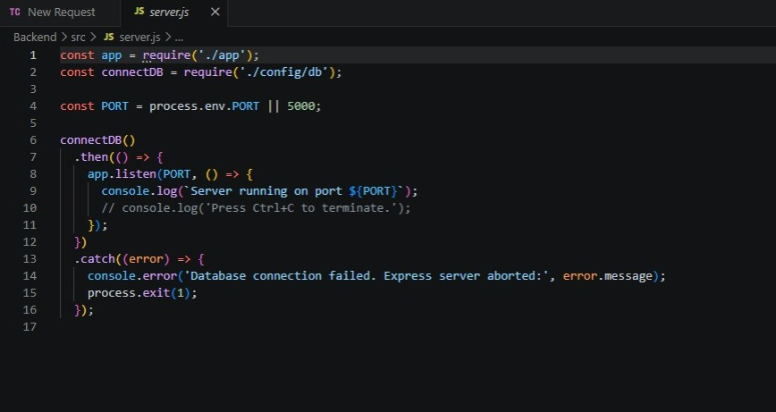

Epic 4: Database Configuration
API Testing Demo :

1. Set Up MongoDB:
- Install Mongoose.
- In your Node.js project directory, run:
- npm install mongoose
- Establish the database connection.
- Create Schemas and Models.

Create Database connection:
Now, ensure that the database is connected before carrying out any actions through the backend. The connection code is similar to the example provided below

Mongoose Schema Definitions
Location Schema:

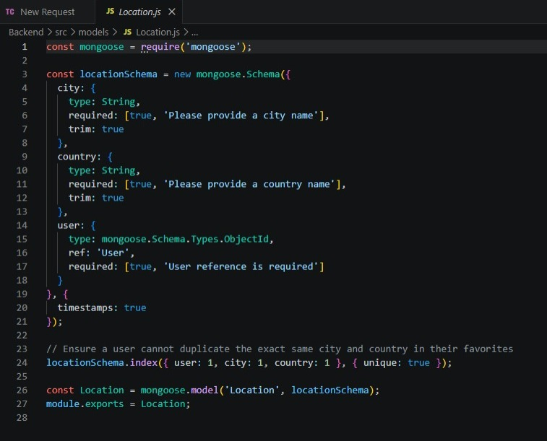

User schema:

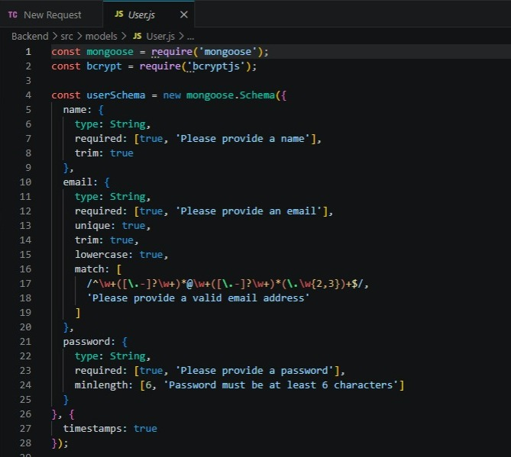
Db connection:
This module creates a connection between the application and MongoDB through Mongoose. It makes sure that the backend communicates with the database before handling client requests.

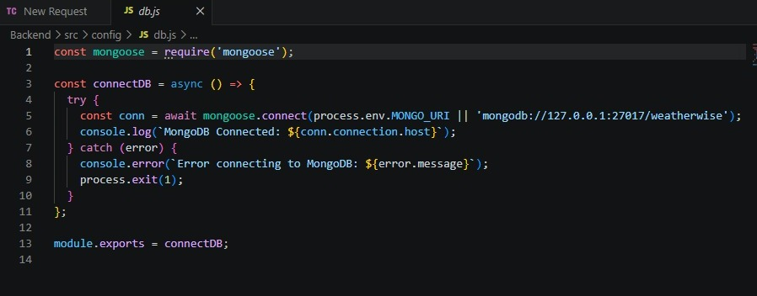

Epic 5: Project Execution:
The AI weatherwise backend can be run locally using Node.js. Before starting the application, make sure MongoDB is running and the required environment variables are set correctly. The backend provides REST APIs that can be tested using Postman or Thunder Client.

Starting the Backend Server
Install all necessary dependencies:
npm install
Launch the development server:
npm start
After successful execution, the server connects to MongoDB and begins listening for incoming API requests.

API Testing:

Register API:
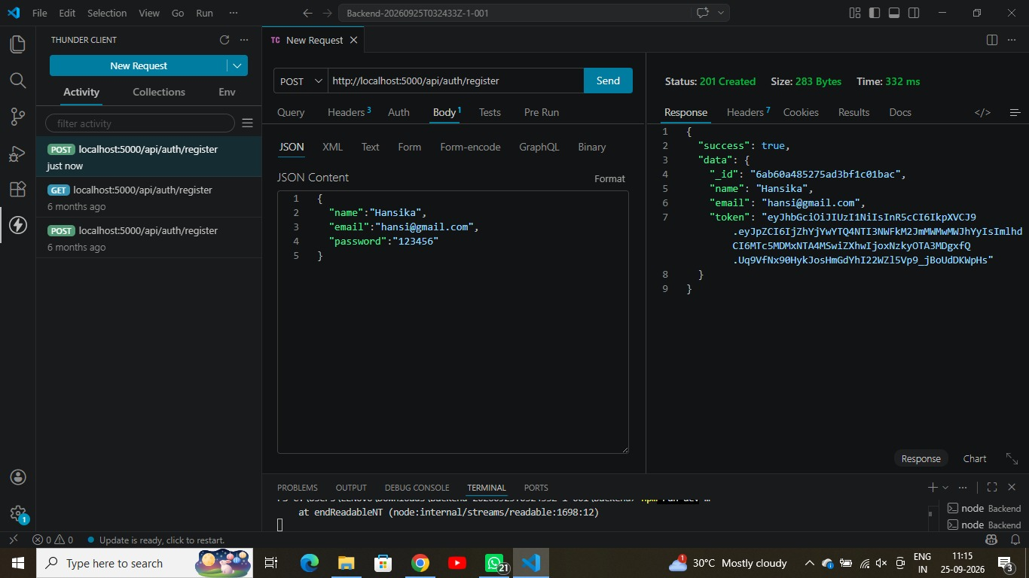
Login API:
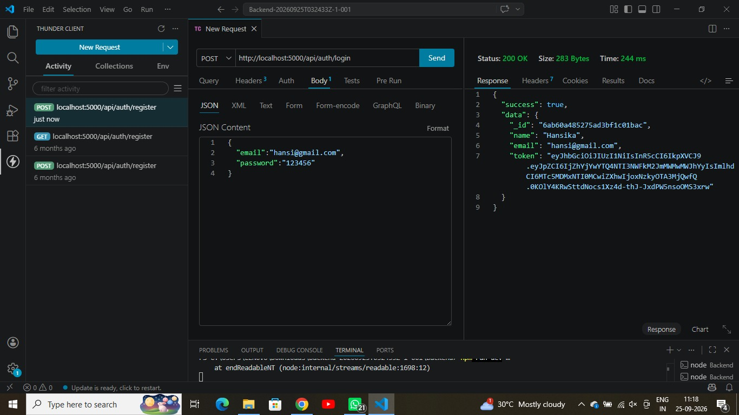

Weather API: 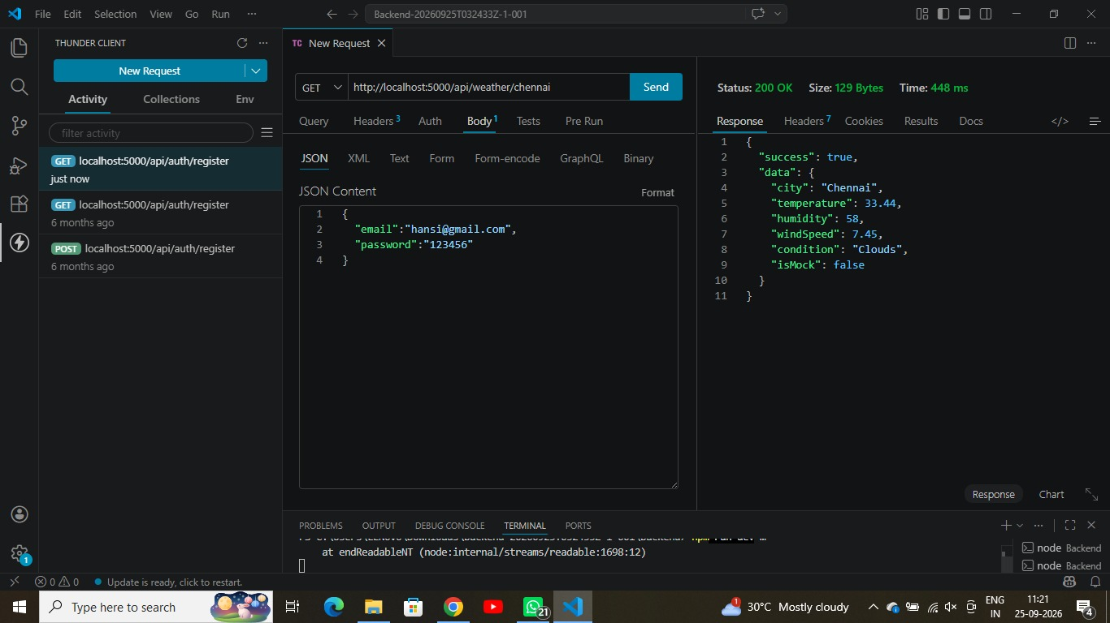

Recommendation API:
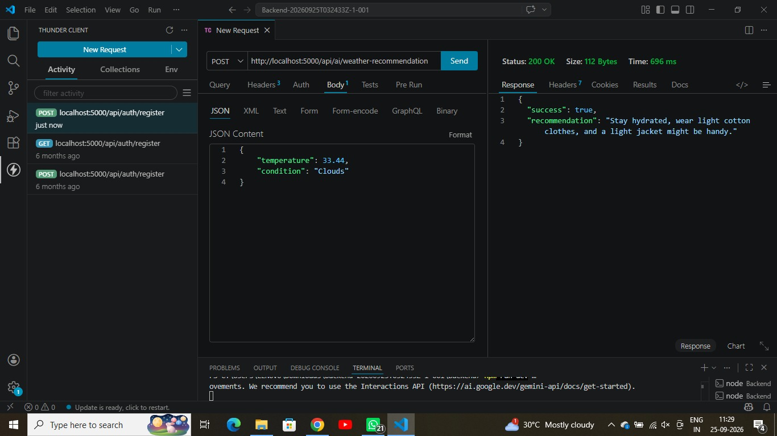

API testing video link : https://drive.google.com/file/d/1nBUsI6kIsG2U4A9644jDuMPUKY-W5CRp/view?usp=drive_link
Demo Video Link: https://drive.google.com/file/d/1iRXERCrxfWh7B0oCk9c4dtxqVFVVWKp2/view?usp=drive_link
Code Drive: https://drive.google.com/drive/folders/1G55_-A38i8UDxCdKx13EpDUR7qEHtZ8U?usp=sharing

